EXPLORATIONS IN mIXED MEDIA
Workshop Series by Kayann Ausherman

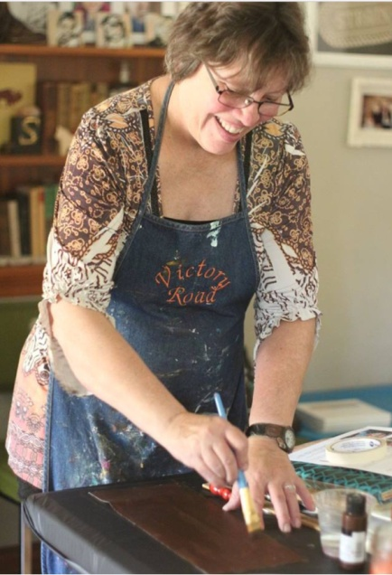
My name is Kayann Ausherman and I have been a mixed media artist my entire life, though did not give myself that label until recent years. I have been published in 20+ magazines, illustrated a children’s book, and sell my artwork in galleries, shops, and online. I have been teaching workshops since 2014, and thoroughly enjoy sharing my processes with others. I love to experiment with different ingredients and techniques and am always discovering new ways of doing things.
This series of eight sessions is a journey through some of my favorite mixed media products, tools, and techniques. We will travel through those in this four day workshop, culminating with pulling it all together in a final project on day 4. I am a firm believer that everyone possesses a creative element somewhere within them, and therefore the process of art should be accessible to all. Both the beginner and advanced artist are welcome.

Day 1- getting started with mixed media

AM – PAINTED PAPERS and MARK MAKING TOOLS – we will learn some mixed media techniques while creating stamps and papers to use in our art making through the week.

Products – acrylic paint, stabilo pencil, water soluble crayons, oil pastels

Tools – printing plate alternatives, craft foam, handmade and found tools

Techniques – mark making, mono printing, simple stamp making, using found papers, adding texture

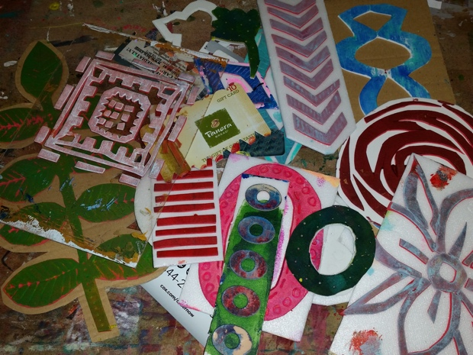
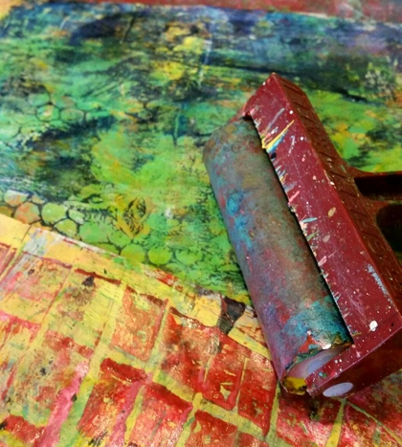
Project – painted papers and mark making stamps to reuse

PM -GUIDED LAYERS (musical easels adapted) Our first art project will use our fun papers and tools made in the morning session, and is a fun introduction to mixed media. It will introduce some of the essential techniques that will be necessary for the week. We will also complete a quick still life .

Products – acrylic paint, matte gel medium, gesso,

Tools – bondo spreader,

Techniques – layering, using found and purchased stencils, letting go, working quickly, adding texture

Project – 11 x 14 still life

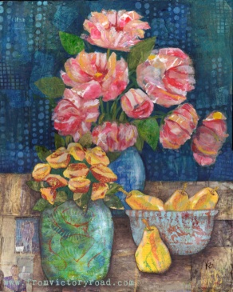

DAY 2 Citra Solv
Citra Solv is one of my favorite mixed media products. It is a concentrated cleaner that dissolves the ink on National Geographic magazine pages.
AM – Citra Solv boot camp
Products – Citra Solv, alcohol ink, alcohol, alcohol blending solution, F. W. Acrylic ink,
Tools – stencils, cotton swabs, skewer
Techniques – altered magazine pages, manipulating the effect, image transfer, embossing,
Project – many altered pages for further use through the week, as well as some “CitraArt”
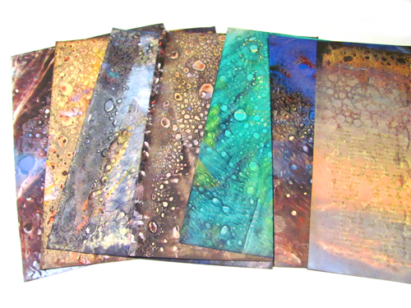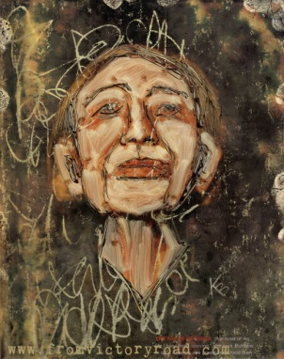
PM – Citra Solv advanced
Products – Citra Solv, NationalGeographic magazines, matte gel medium, Derwent Inktense pencils, Acrylic glazing medium
Tools – Saran Wrap, stencils,
Techniques – Citra Solv backgrounds, painting with paper
Project – a finished 11 x 14 mixed media artwork using Citra Solv altered papers.
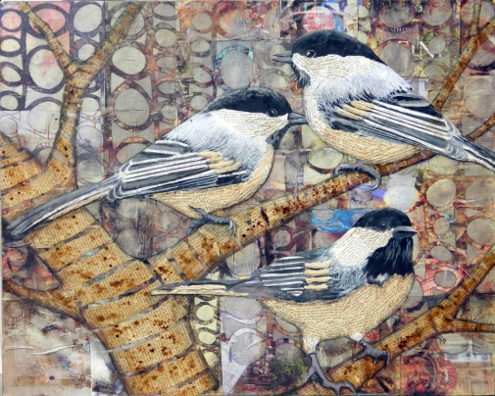

Day 3 – mix it up

AM – Mix it up

Products – watercolor, acrylic, airbrush medium, YUPO paper, masking fluid, alcohol, ink, blending solution, workable fixative, sea salt, and more!

Tools – pipette, straw, fineline dispenser

Techniques – resists, making your own high flow paint, adding marks, mounting paper on board

Project – an 11 x 14 sheet of highly layered special effects Yupo paper

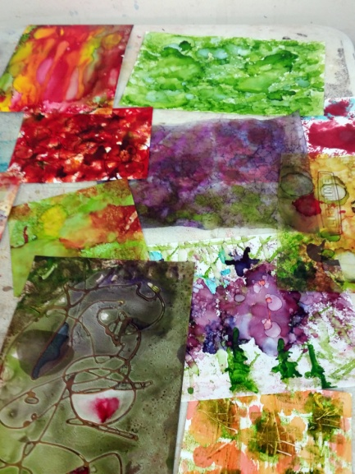

PM – Reverse Painting – using the sheet painted in the morning session as the base for a reverse painted finished piece.

Products – gesso, acrylic paint, Derwent Inktense, stabilo pencil

Tools- stencils, mark making tools

Techniques – simplifying shapes to silhouette, mark making, adding texture

Project – an 11 x 14 panel

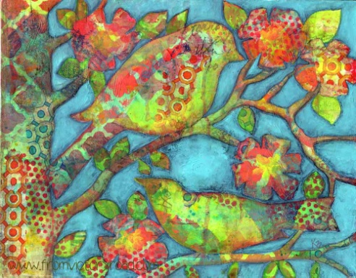

day 4 – bring it all together – from conception to completion!

AM – From conception toward completion.

Products – All of the above!

Tools – All of the above!

Techniques – layering, mark making, painting with paper, reverse painting, adding whimsy, how it all ties together

Project -Use what we have learned to create a background and additional tips on adding whimsy to the subject matter.

16 x 20 surface

PM – Finishing Touches

Products – “special” embellishments, ink, glazing, glass bead gel

Tools – pens and dip pens

Techniques – glazing, adding whimsy, adding detail, sign and coat

Project – finish 16 x 20 started in am

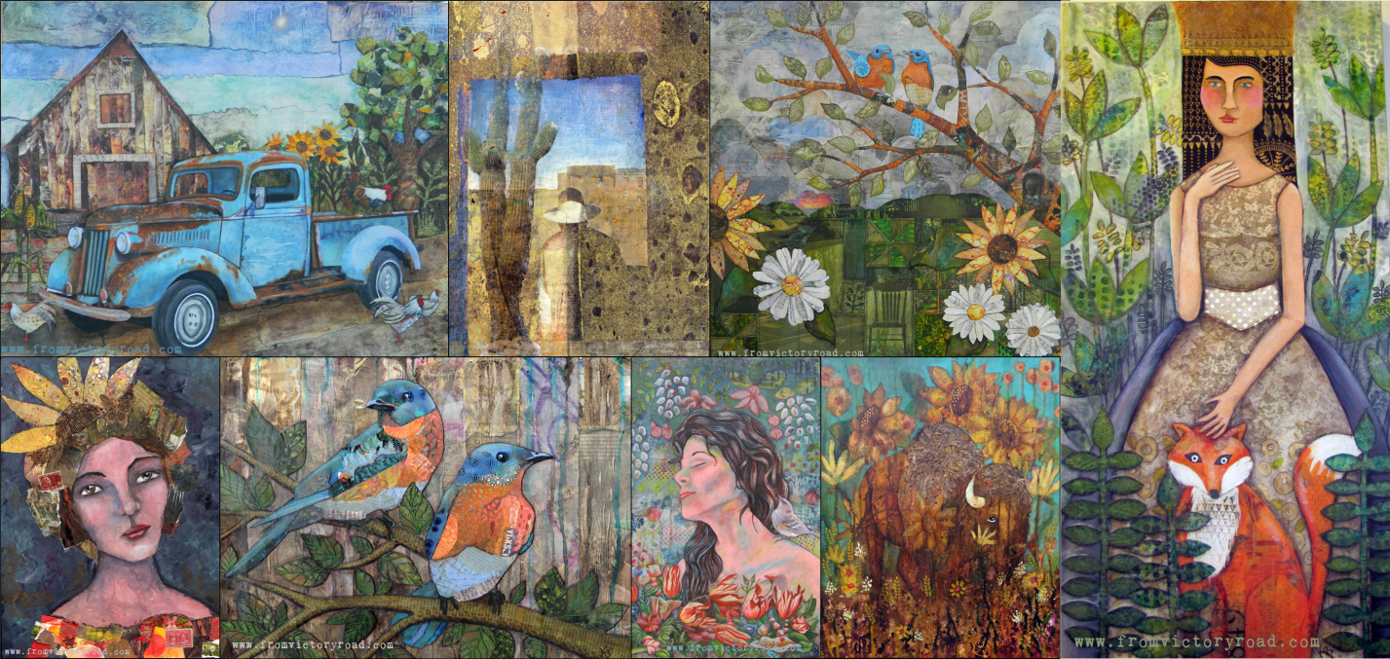

Supply List: (please mark all of your supplies!)
Basic supplies
- Acrylic paint
- Gesso
- Brushes
- Matte gel medium ( I prefer Liquitex)
- Palette knife
- Scissors
- Baby wipes
- Water spray bottle
- Apron
- 3 National Geographic magazines, year 2000 or NEWER
- OPTIONAL, but suggested - Reference photos to work from, or a great imagination!
- OPTIONAL - Rubber gloves
Surfaces:
- Day 1 am - none
- Day 1 pm -11 x 14 canvas board, wood panel, or other rigid surface
- Day 2 am-none
- Day 2 pm 11 x 14 canvas board, wood panel, or other rigid surface
- Day 3 am 11 x 14 inch Yupo paper – available for purchase at workshop for $2 ea.
- Day 3 pm 11 x14 wood panel or masonite
- Day 4 am 16 x 20 cradled wood panel, or other rigid surface and dimension of choice
- Day 4 pm - none

I will provide all the rest of the materials needed, plus a little gift of supplies to take home, and a full color handout each day!

